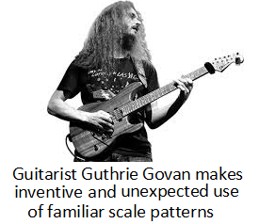
It’s not enough to simply play the right scales and arpeggios. Try to invert your patterns from the previous lesson; and then, re-arrange your notes in a random order.
(If this is difficult, first begin by laying out your ideas on the stave.)

Remember, silence can be just as powerful as playing a note
- Think through or look back at your patterns – could your phrase enter at a point in the bar other than the first beat?
- Which notes in your pattern could you miss out? Experiment with omitting various notes and seeing how this changes the feel of your phrases

If you didn’t find this exercise challenging, try applying your patterns to an entire chord progression (option 1 from the video, option 2 is 12 bar blues in C):
